CS 340 README – Project Two- Sean Mills

About the Project/Project Title
This project is a MongoDB web application dashboard that was built using Python and the Dash framework. The dashboard connects to a MongoDB database that contains the Austin Animal Center (AAC) Outcomes dataset and allows the user to filter and visualize dogs that may be a suitable candidate for training involving search and rescue. The application provides the user with an interactive data table with filtering controls, a breed distribution pie chart, and a geolocation map. The dashboard retrieves the data directly from MongoDB through a reusable CRUD Python class that handles communication with the database.

Motivation
The goal of this project is to create a user-friendly dashboard that allows the users to interact with a MongoDB database without having to write the database queries manually. Instead of working directly in the Mongo shell, the users can select rescue categories and quickly see the filtered results displayed in the charts and the map. It follows a design known as MVC, which stands for Model-View-Controller, where MongoDB serves as the model, Dash serves as the view, and the Python callback functions act as the controller.

Installation
To use the project, you will need the following tools to be installed:
- Python: Python is required to run the CRUD module and testing script. You can download Python from the official Python website.
- MongoDB: MongoDB is used to store the Austin Animal Center dataset. MongoDB can be installed locally from the official MongoDB website.
- Codio: Codio is the development environment used to write, run, and test this project, and can be accessed from the official website.
- Jupyter Notebook: Jupyter Notebook is used to run and test the CRUD functionality and to launch the ProjectTwoDashboard.ipynb file. It is included in the Codio development environment. However, if the project is being run outside of Codio, Jupyter Notebook can be installed locally using pip with the command “pip install notebook” or downloaded from the official Jupyter website. Note: All pip commands can be run through a system terminal, such as the terminal inside the Codio workspace or a local command prompt.
- PyMongo: PyMongo is the Python library that is used to connect Python code to MongoDB. If PyMongo is not already installed, you can install it using pip with the command “pip install pymongo”.
- Dash: Dash must be installed to build and run the web application. It can be installed using pip with the command “pip install dash”.
- Dash Leaflet: Dash Leaflet is required for the interactive maps. To install, use pip with the command “pip install dash-leaflet”.
- Plotly: Plotly is needed for the chart visualizations. To install Plotly, use pip with the command “pip install plotly”.
- Pandas: Pandas is required to use data manipulation. To install Pandas, use pip with the command “pip install pandas”.

Getting Started
To use this project, you must first have a MongoDB database that contains the Austin Animal Center Outcome dataset. The database needs to be named aac, and the collection must be named animals, otherwise it won’t work. A MongoDB user account also needs to be created and named aacuser and must have read and write permissions.
Once you have the database configured, you need to place the following files into the same working directory:
- ProjectTwoDashboard.ipynb
- CRUD_Python_Module.py
- Grazioso Salvare Logo.png
Once that is done, open the notebook and run all the cells to launch the dashboard.
MongoDB Python Driver
This project uses MongoDB and was chosen because it works well with Python and makes it easier to store and filter large sets of the shelters data. Dash was also chosen because it allows for an interactive web application to be built within Python, without needing any separate JavaScript code. Combined, these tools support the MVC structure that is used.
This project also uses the PyMongo library as the Python driver for MongoDB. PyMongo was chosen because it is the official MongoDB supported driver for Python and it provides direct access to the MongoDB features like authentication, queries, updates, and deletions. It works well because it integrates cleanly with the Python applications.

Usage
This dashboard allows the users to filter dogs based on three rescue categories: Water Rescue, Mountain or Wilderness Rescue, and Disaster or Individual Tracking. There is also a fourth option, which is reset. Reset brings the dashboard back to its default settings before a filter was applied.
When a filter is selected, the dashboard will execute a MongoDB query using the CRUD Python module. The filtered results are then displayed in the interactive data table. The breed distribution pie chart and the geolocation map will automatically update based on the filtered dataset. The data table also supports pagination, sorting, and filtering to improve its usability. Duplicate records were also removed from the dataset by using the animal_id field to make sure the results are accurate.

Code Example
The dashboard imports the reusable MongoDB class and creates an instance so it can connect to the database, as shown here:
from CRUD_Python_Module import AnimalShelter
username = "aacuser"
password = "your_password"
shelter = AnimalShelter(username, password)
An example of a filtering query used in the dashboard is also shown below:
if filter_type == 'water':
query = {
"$and": [
{
"$or": [
{"breed": {"$regex": "Labrador Retriever", "$options": "i"}},
{"breed": {"$regex": "Chesapeake Bay Retriever", "$options": "i"}},
{"breed": {"$regex": "Newfoundland", "$options": "i"}}
]
},
{"sex_upon_outcome": "Intact Female"},
{"age_upon_outcome_in_weeks": {"$gte": 26, "$lte": 156}}
]
}
The query results are then converted into a Pandas DataFrame and then displayed in the dashboard.

Tests
When testing the project, it was completed by running the ProjectTwoDashboard.ipynb file and then verifying that all of the dashboard components updated correctly whenever the filters were applied. Each rescue type filter was tested individually, and by doing so it confirmed that the data table displayed the correct filtered results, the breed distribution chart updated dynamically, and the geolocation map displayed the correct marker whenever a row was selected.
The Reset option was also tested to make sure that it returned all of the data to how it was before being filtered. Additionally, the dataset was reviewed to make sure that duplicate records were removed correctly and did not appear within the dashboard results.

Screenshots
Screenshot(s) #1: Shows the successful import of the Austin Animal Center Outcomes CSV file into the aac database by using mongoimport.
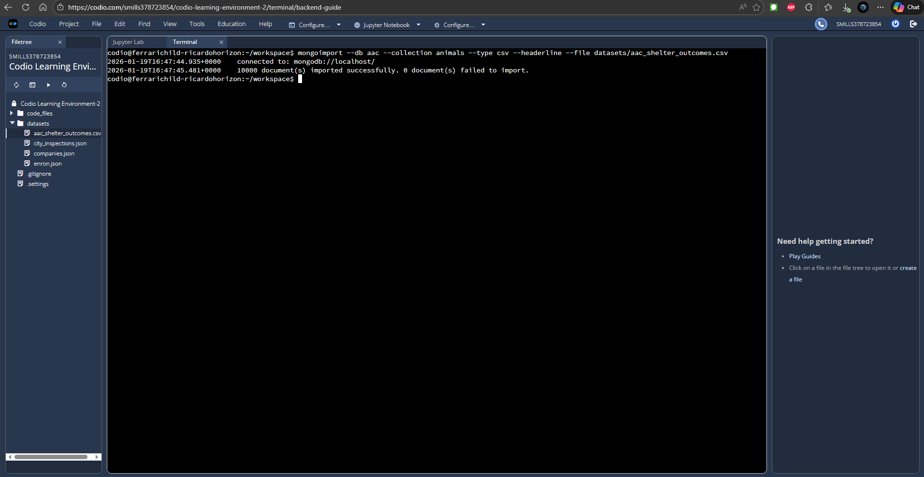

Screenshot(s) #2: Shows the creation of the aacuser MongoDB account and the successful authenticated login by using the mongo shell. By using the connectionStatus command, it confirms that the user is authenticated and has read/write access to the aac database.
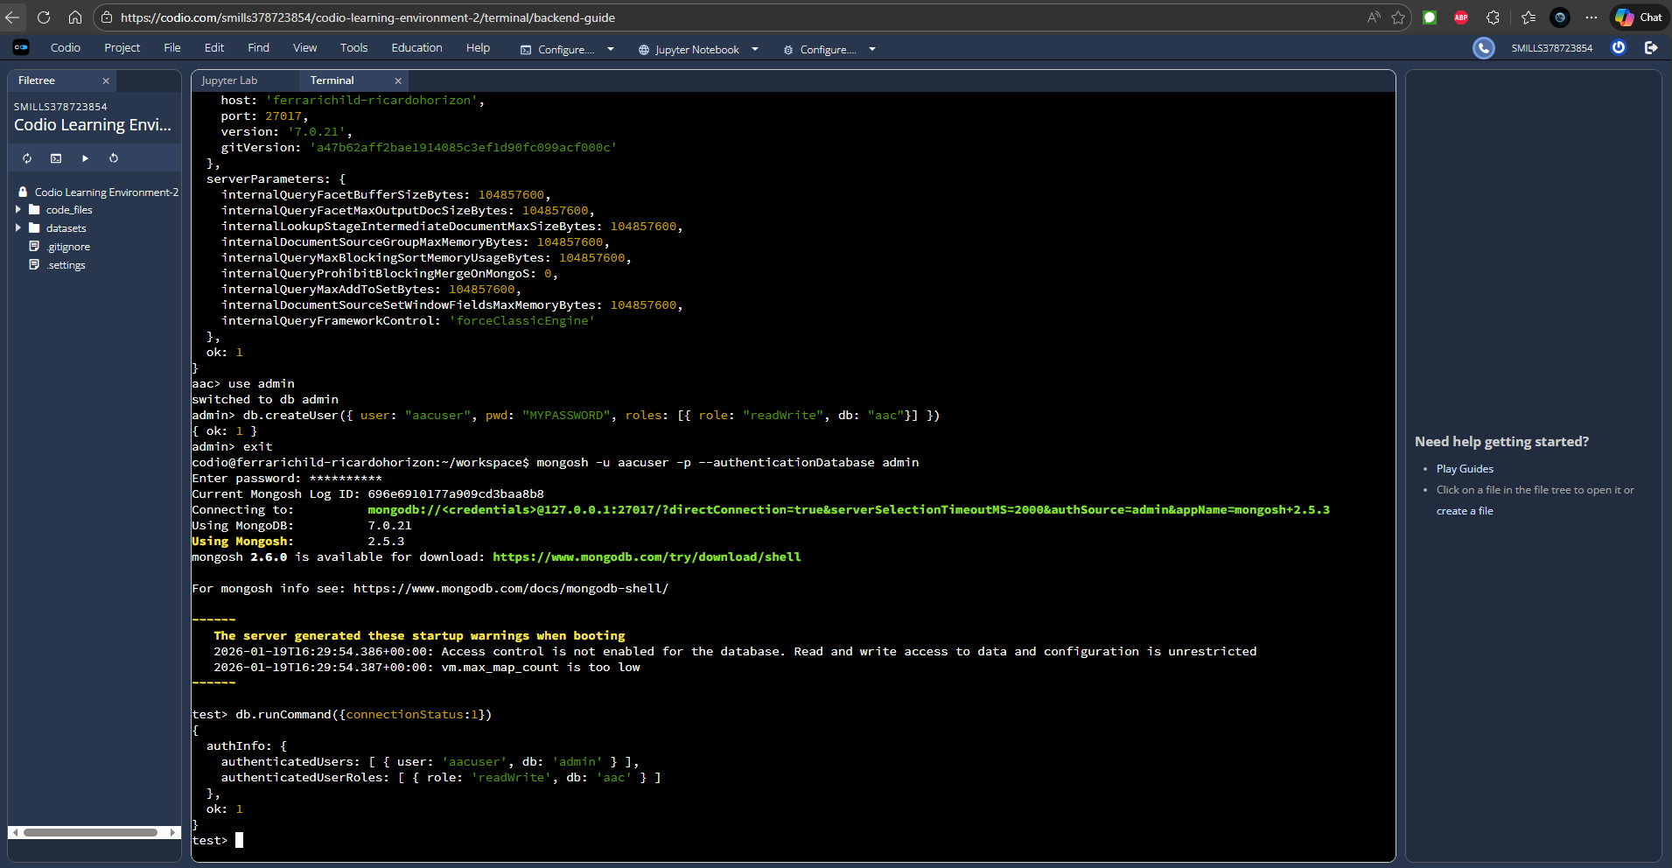

Screenshot(s) #3: Shows the dashboard with its default selection (reset).
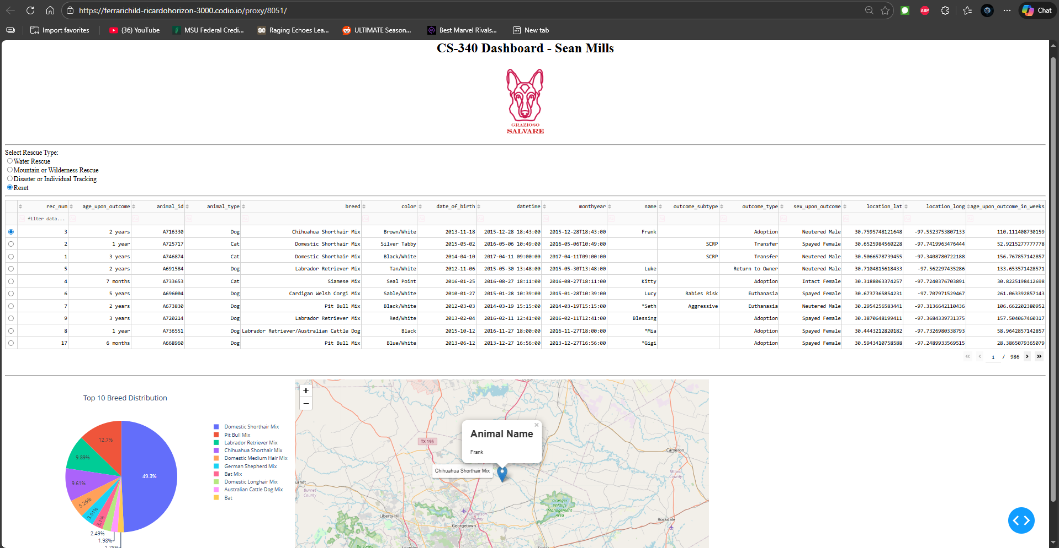

Screenshot(s) #4: Shows the dashboard with “Water Rescue” selected. 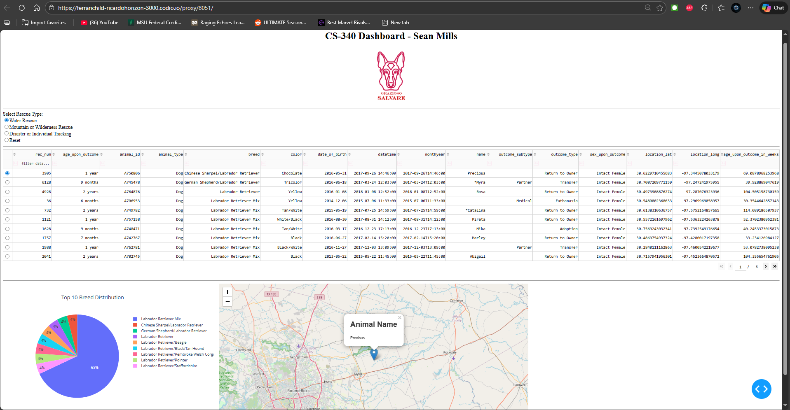

Screenshot(s) #5: Shows the dashboard with “Mountain or Wilderness Rescue” selected.
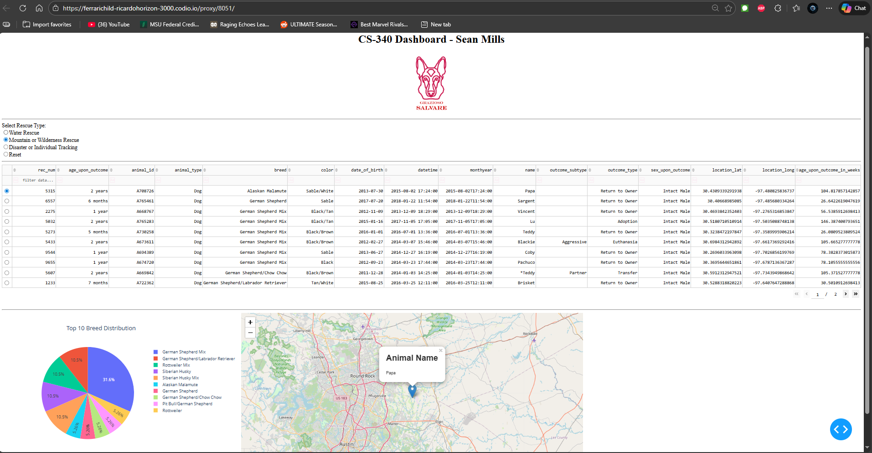

Screenshot(s) #6: Shows the dashboard with “Disaster or Individual Tracking” selected.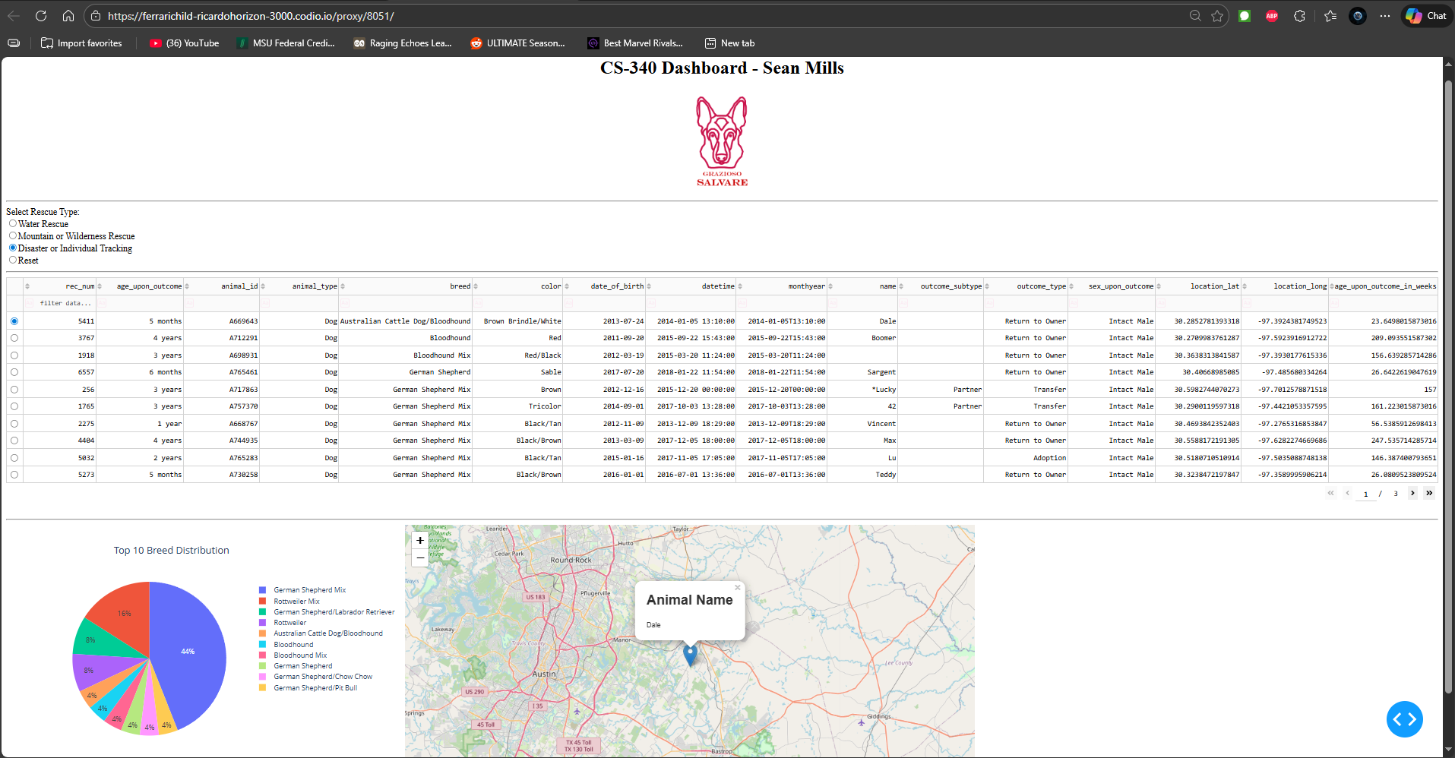

Screenshot(s) #7: Shows the dashboard with sorting options applied. In this instance, the data is being sorted by “color” in ascending order.
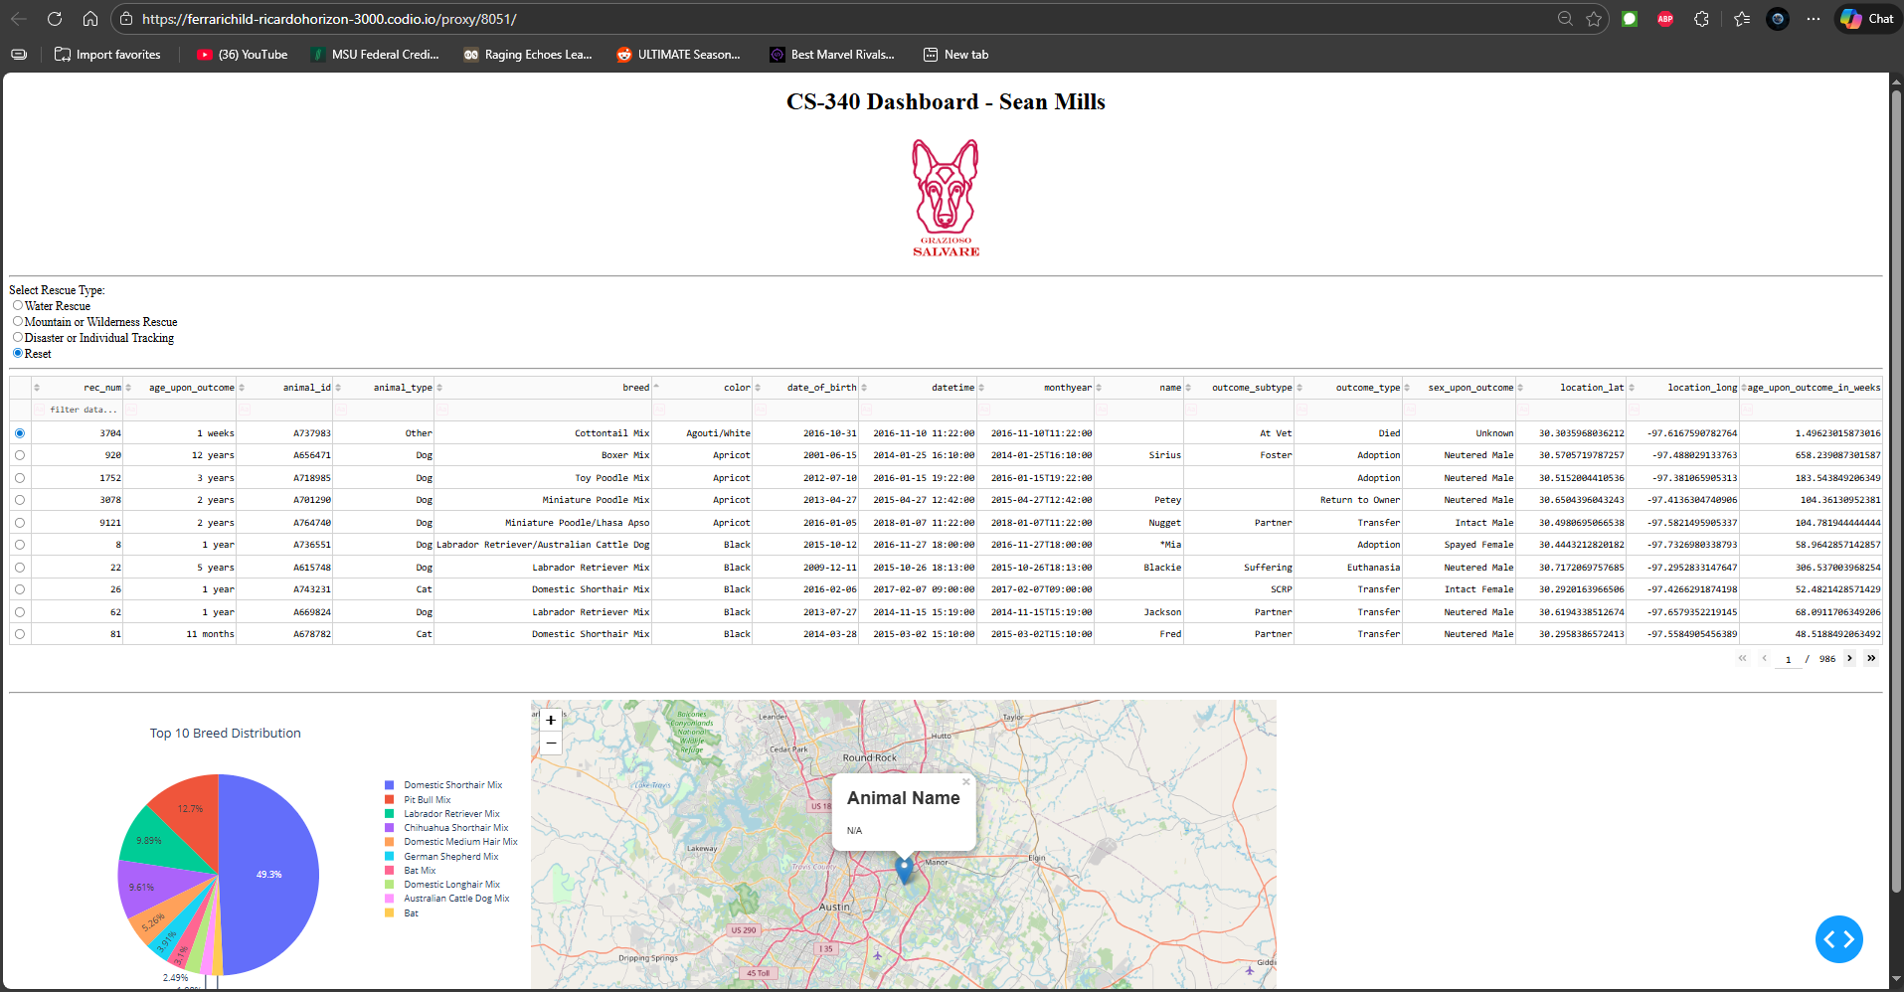

Screenshot(s) #8: Shows the dashboard with filter settings applied. In this instance, the user is searching for “Bird” and also has the sorting options applied by color in descending order.
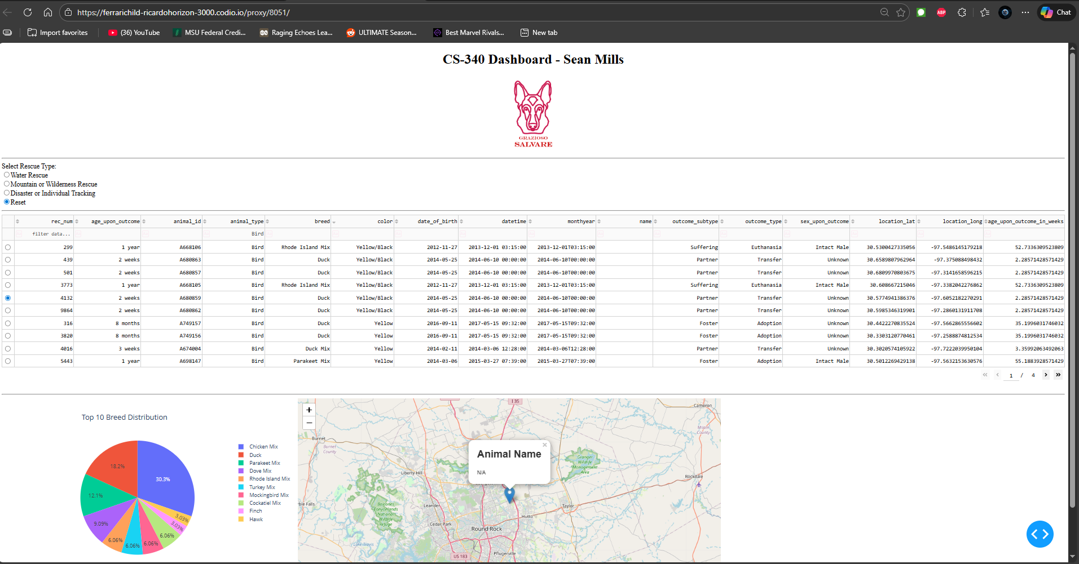

Steps To Complete the Project

This project was completed in several steps. First, the Austin Animal Center Outcomes dataset was imported into MongoDB using mongoimport. A MongoDB user account named “aacuser” was then created with read and write permissions to the aac database. Next, the “CRUD_Python_Module.py” was used to have communication between Python and MongoDB. After confirming that the CRUD functionality worked as intended, I began work on the dashboard development

For the dashboard development, an unfiltered data table was created to display all animal records from the database. After confirming the data loaded correctly, MongoDB queries were written to support the three rescue categories using $and, $or, and $regex conditions.

Interactive radio buttons were then added to allow the users to select rescue categories. Callback functions were then written to update the data table based on the selected filter.

After the data table was responding correctly, two dynamic charts were created, which were a breed distribution pie chart and a geolocation map. Additional checks were also added to prevent errors when a row wasn’t selected.

Finally, the dashboard was tested by applying each filter option and verifying that the table and charts updated correctly. Screenshots were captured and included within the README to show functionality.

Challenges
Some of the challenges I encountered when making this project were writing the MongoDB queries so that they correctly matched the rescue type requirements from the specifications table. Each rescue category needed multiple conditions, like a specific breed, sex, and age ranges. Building these queries using $and, $or, and $regex took some time testing to make sure the correct animals were being returned. I had to adjust the filter several times to confirm that the dashboard was showing accurate test results for each rescue type. Ultimately I settled on using $regex, as this gives the user a wider selection of breeds with the type they are looking for.
Another challenge was handling how the dashboard updated when the users interact with it. When filters were selected or when no row was chosen in the data table, it would cause errors in the map callback. To fix this issue, I had to add checks into the code to make sure a valid row was selected before the map tried to use the data. Adding these checks prevented the dashboard from crashing when users changed their filters or searched the table.

Contact
Sean Mills

